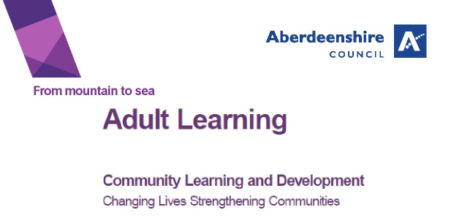

**“Improve Your Skills” course**

Do you want to improve your reading, writing or number skills?

Do you want to gain a qualification?

Our course will help you become more confident with numbers, reading, writing, listening and speaking.

You will be learning with other adults, working towards an SQA level 3 and or 4, leading to a SQA qualification.

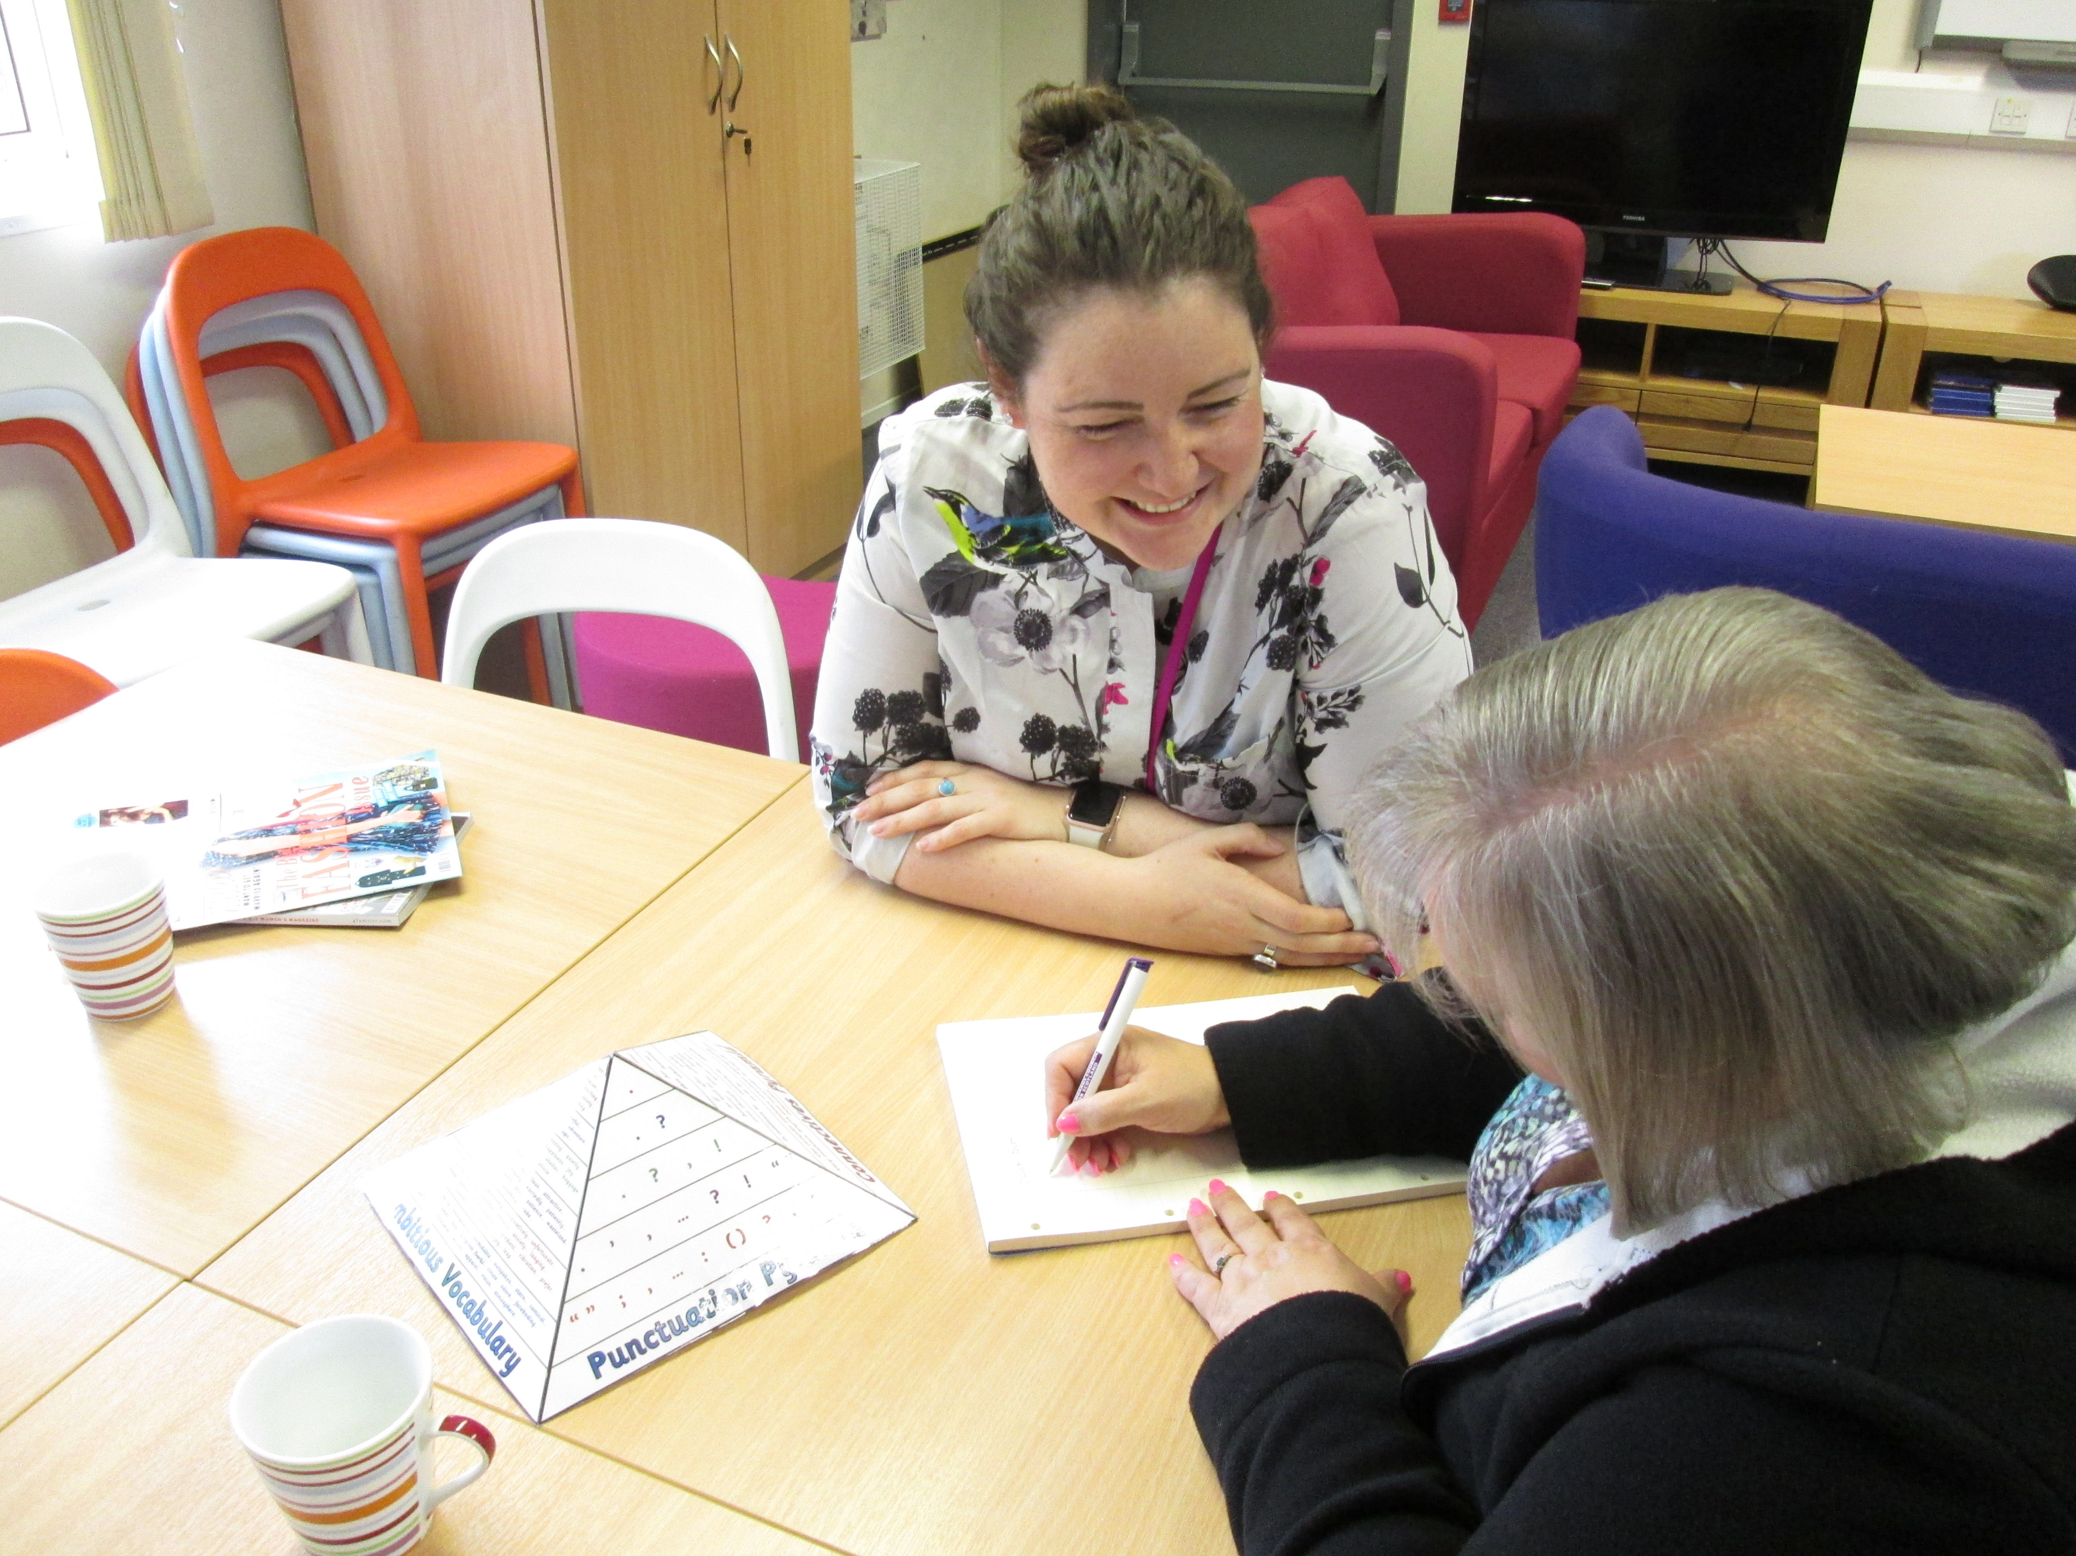

The course is on every Monday for 8/10 weeks and is **FREE**

**Starting 2nd September** **2019**

10.15am – 12.15pm

Ellon Library, Station Road, Ellon, AB41 9AE

For more information – see below

|  |  |
| --- | --- |
| Contact | Vikki Carpenter |
| Telephone | 01358 727910 or text 07789 654273 |
| Email | vikki.carpenter@aberdeenshire.gov.uk |